Hi everyone! Once again, it's time for our annual AHS Trojan Band Mulch Fundraiser. As a member of the band, we need your help during our annual fund drive for our 2018-2019 school year.

We are a competitive, award-winning marching band with over 175+ Instrumentalists and 20+ Danceguard members. We compete against other marching bands, in addition to performing and providing spirit and support at all Anderson High School football games. We also march in community parades to support our local neighborhood. It’s a lot of fun, but requires a lot of work!

Putting on a competitive marching band show is expensive. The cost of instructors, equipment, uniforms, props and travel adds up to tens of thousands of dollars each year for our band, but we also gain things money cannot buy. We learn the value of discipline, hard work and teamwork along with having the opportunity to be part of something bigger than ourselves.

We are asking our friends, neighbors and relatives to participate in our fundraiser! One hundred percent of your contribution will go directly toward supporting our band activities.

We are selling two types of mulch –Black Label and Hardwood.

Black Label |  |  | Hardwood
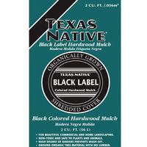 | 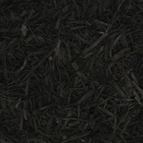 |  | 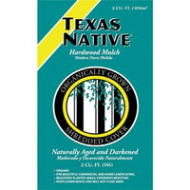 | 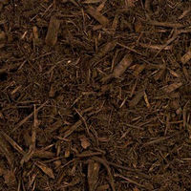

Price: $5 per bag

Delivery: FREE to addresses zoned to Anderson HS for orders of 10 bags or more.
*Pick up at Anderson High School for smaller orders or homes outside of AHS zoning area.

Bulk Mulch Option: This year, we also have a new option of BULK mulch by the cubic yard, delivered to any address in the Greater Austin area.

Order before March 26th!
Delivery Date: Saturday, April 6th
*You do not need to be home for delivery

If you’re interested in learning more, here is a link to a video of our November 2018 show where we placed 1st at the US Bands competition - https://www.youtube.com/watch?v=qLxmYbaTj9o

Thank you in advance for your kindness and generosity!
Your friends in the Anderson High School Band and Danceguard

